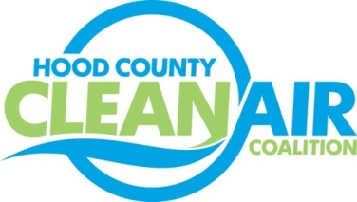
Meeting: Tuesday, December 2, 2014
American Town Hall
220 N. Travis Street, Granbury, Texas 76048
8:30-9:30 a.m.

Agenda

- Call Meeting to Order
- EPA Updates – Carrie Paige
- Regional Updates – Chris Klaus
  - Hood County Clean Air Coalition Won the Air North Texas Outstanding Initiative Award!
  - Clean Fleet Policy: For more information: www.nctcog.org/fleetpolicy.
  - Dallas-Fort Worth Clean Cities
    - Meeting: December 16, 2014, 1:30 www.dfwcleancities.org.
    - Looking for Annual Sponsors: Visit www.dfwcleancities.org/involved/sponsor.asp or email cleancities@nctcog.org for more information
    - National Biodiesel Conference, January 19-22 at the Fort Worth Convention Center. Register online at www.biodieselconference.org/2015.
  - Air Quality Funding Opportunities: www.nctcog.org/aqfunding
- Local updates – Michelle McKenzie
  - Review of November Meeting Summary
  - TCEQ Response Letter to EPA Ozone Review
  - Air North Texas Meeting Report
  - Regional Air Quality Conference Call Report
  - Rider 8 Review of Projects
    - Monthly Budget Review for October
    - Status of Projects
    - Rent / Utilities Agreements
  - Tax ID for Coalition
  - Status Transfer of Coalition Funds from Lake Granbury EDC to Granbury Administration
  - Upcoming Executive Board Officer Elections
- Discussion
- Adjourn

